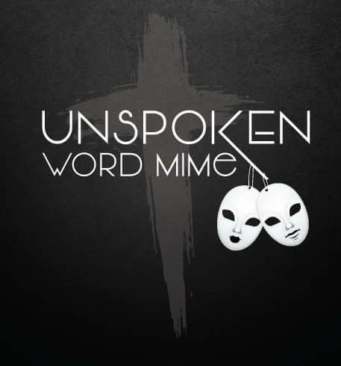

Sponsorship Tiers
Master Mime Tier Sponsors ($500)
- 2 Conference T-shirts
- Recognition on UWMC2018 promotional material
- Conference Vendor Booth (3 nights)
- 2 Free VIP seating at concert
- DVD of UWMC2018
- Recognition during concert
Mime Tier Sponsors ($350)
- 1 Conference T-shirt
- Recognition on UWMC2018 promotional material
- Conference Vendor Booth (1 night)
- 1 VIP seating at concert
- DVD of UWMC2018
- Recognition during concert
Novice Tier Sponsors ($250)
- 1 Conference T-shirt
- Recognition on UWMC2018 promotional material
- 1 VIP seating at concert
- DVD of UWMC2018
- Recognition during concert

